**Exercise 2 : E-commerce Platform Search Function**

### **What is Big O Notation?**

Big O notation is a mathematical way to describe the **efficiency** of an algorithm as the input size increases. It focuses on the **worst-case, average-case, and best-case** performance, helping developers choose the most optimal algorithm for their needs.

### Why Matters:

* Helps compare multiple algorithms
* Predicts scalability
* Guides optimization

### For Search Operations:

| Case | Linear Search | Binary Search |
| --- | --- | --- |
| Best Case | O(1) (first item) | O(1) (middle item) |
| Average Case | O(n/2) | O(log n) |
| Worst Case | O(n) | O(log n) |

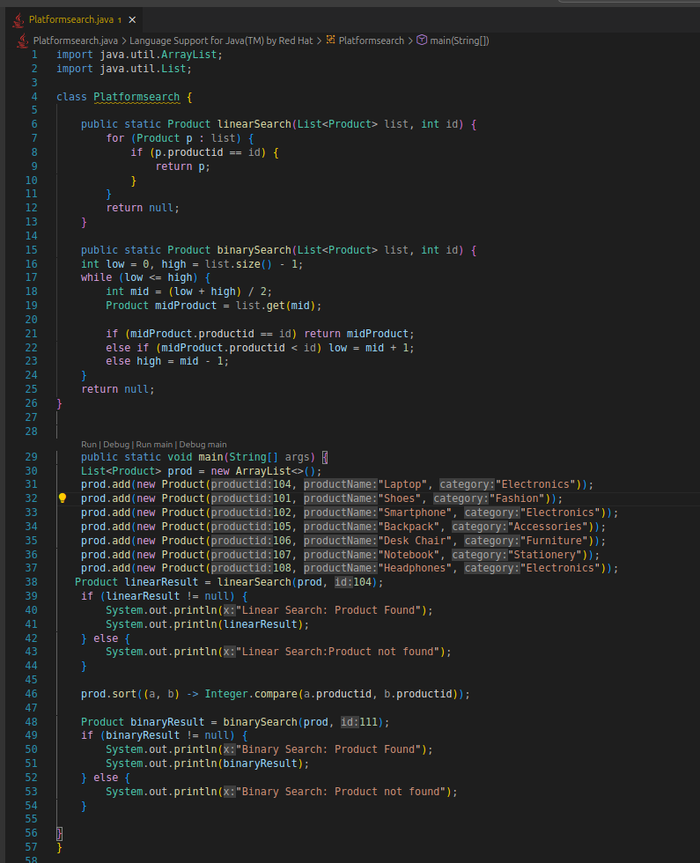

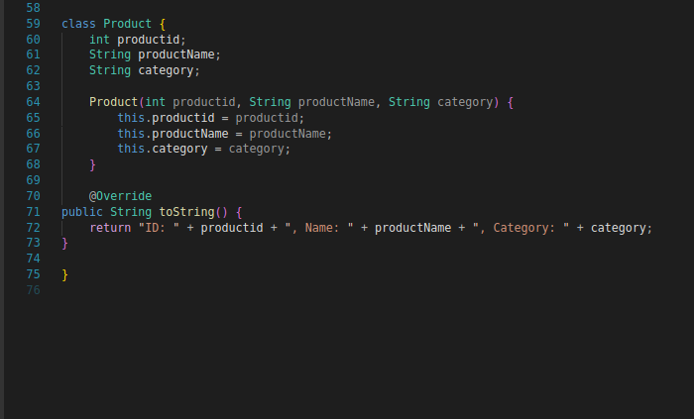

**Output** :

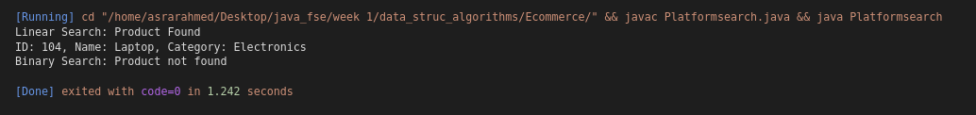

## Algorithm Analysis

### Linear Search

* Scans each item in the list one by one.
* When the data is **unsorted** or the list is **small**.
* **Time Complexity**:
  + Best: O(1)
  + Average: O(n/2)
  + Worst: O(n)

### Binary Search

* Repeatedly divides a **sorted** list in half to locate the target.
* When the list is **sorted** and size is **large**.
* **Time Complexity**:
  + Best: O(1)
  + Average/Worst: O(log n)

For an optimized e-commerce search on product ID,binary search is more suitable but requires sorting .